Software Requirements Specification

for

Elevator Control Simulation Software

Version 2.0 approved
Prepared by Pod 2
EECE 419
November 24th, 2010
Table of Contents
1. Introduction 1
1.1 Purpose 1
1.2 Document Conventions 1
1.3 Intended Audience and Reading Suggestions 1
1.4 Project Scope 2
1.5 References 2
2. Overall Description 3
2.1 Product Perspective 3
2.2 Product Features 3
2.3 User Classes and Characteristics 3
2.4 Operating Environment 4
2.5 Design and Implementation Constraints 4
2.6 User Documentation 5
2.7 Assumptions and Dependencies 5
3. System Features 5
3.1 Viewing Existing Simulation Templates 6
3.2 Creating a Simulation Template 6
3.3 Editing a Simulation Template 7
3.4 Deleting a Simulation Template 8
3.5 Starting a Simulation 9
3.6 Stopping a Simulation 10
3.7 Updating Simulation Configuration 10
3.8 Viewing Simulation Results 11
3.9 Configuring Web Server 12
3.10 Observing a Simulation 12
4. External Interface Requirements 13
4.1 User Interfaces 13
4.2 Hardware Interfaces 13
4.3 Software Interfaces 14
4.4 Communications Interfaces 14
5. Other Nonfunctional Requirements 14
5.1 Performance Requirements 14
5.2 Safety Requirements 14
5.3 Security Requirements 14
5.4 Software Quality Attributes 14
6. Other Requirements 1
5
Appendix A...................................................................................................................................16

Appendix B...................................................................................................................................22

Revision History
Name | Date | Reason For Changes | Version
Kevin Chou | Oct. 24 | Assumptions (2.7) and selection of Speed Features. Updates to 2.3.3, 4.2, 4.3, 5.2 | 1.1
Kevin Chou | Nov. 2 | Section 6.0, reword | 1.2
William Chang | Nov.24 | Updated 3.8, 3.9, and 3.10 | 1.3
Janina Fedjko | Nov. 26 |  | 2.0

1. Introduction

1.1 Purpose

This document identifies the requirements of the first release of our Elevator Control Simulation software. Our purpose is to specify, design and develop a graphical, real-time, standalone software system that allows the user to analyze and evaluate several elevator dispatching algorithms. The system will carry out its functions through collaboration between two graphical interface options, namely the web-based and PC components, while delivering accurate, reliable and complete results.

1.2 Document Conventions

In this document, the words that are used to define significance of each particular requirement are capitalized. These words are [1]:

- “MUST”
- This term implies that the item is an absolute requirement of the specification. An implementation is not compliant if it fails to satisfy one or more of the “MUST” requirements.
- “SHOULD”
- This term implies that there may exist valid reasons to ignore this item.
- “MAY”
- This term implies that an item is truly optional.

1.3 Intended Audience and Reading Suggestions

This document provides an overall description of the system and its features, as well as a thorough explanation of its functional, non-functional, and interface requirements. The following sub-sections describe for whom this document is intended, and provide recommendations in regards to the content pertinence for each user.

1.3.1 Project Managers and Designers

The project manager and software designers are advised to review the entire document in order to achieve the most thorough comprehension of the requirements.

1.3.2 Testers

Software testers are recommended to review the material provided in sections 3, 4 and 5 in order to familiarize themselves with the specifications of the system. Meticulous analysis of these sections will aid the quality assurance department of our company in developing a detailed and efficient product testing plan.

1.3.3 Marketing Staff

The marketing staff is recommended to study the material provided in section 2 in order to gain thorough knowledge of the features and capabilities of the product, and design the marketing campaign accordingly. If seeking a more in-depth overview of each feature, pertinent information can be found in section 3.

1.3.4 Users

Users are recommended to familiarize themselves with the overall description of the software, as outlined in sections 2.1 – 2.4, in order to gain understanding of the basic features and requirements of the product.

1.4 Project Scope

The Elevator Control Simulation software is a tool for our company's engineering and quality assurance (QA) departments, designed to aid in the future developments of our elevator control software. The tool provides the user with the ability to execute real-time elevator simulations and analyze the resulting data. The following sub-sections discuss the objectives and benefits of this product.

1.4.1 Objectives

The main objective of the creation of this software is to provide the engineering department with a tool for testing and visualizing new scheduling and failure recovery algorithms for elevator control systems. Through the use of this tool, the QA department will be able to maintain a collection of repeatable load scenarios and their performance results, which can be utilized to improve the control of a system upon software maintenance or updating.

Achieving the objectives outlined above compliments our business objective of gaining an industry-wide reputation for producing the safest and most efficient elevator control software.

1.4.2 Benefits

The Elevator Control Simulation tool is intended to aid our company in reducing the number of defects reported in our software. Through the use of this system, we are aiming to reduce the risk of potential disasters involving our future products.

1.5 References

[1] Braden, R., “Requirements for Internet Hosts – Application and Support”, <http://datatracker.ietf.org/doc/rfc1123/>, October, 1989. (October 3, 2010).

2. Overall Description

2.1 Product Perspective

The Elevator Control Simulation tool is an original, self-contained software product. The need for this product stems from the lack of testing tools in our current development process.

2.2 Product Features

This section provides a high-level summary of the three main functions of the Elevator Control Simulation software, namely template management, simulation execution and results analysis.

2.2.1 Template Management

Users are provided with the ability to manage a collection of simulation templates. Each template is given a unique name and defines all basic inputs to a simulation (i.e. number of floors, scheduling algorithm, etc.). In addition, a template defines a timeline of events to occur during simulation. Examples of events are elevator requests, component failures, and elevator decommissioning. Users are able to create, edit, list and delete templates through a web-based interface.

2.2.2 Simulation Execution

Users are provided with the ability to execute a simulation based on the inputs outlined in a chosen template. During simulation, the system displays the real-time activity of each elevator. This may include waiting passengers, current floor, and current velocity of the elevator. Users are able to add and remove events from the timeline during simulations.

2.2.3 Results Analysis

Simulation results are stored in sets of graphs and data tables. These results may include the complete timeline of events that have occurred during the simulation, as well as the inputs outlined by the simulation template and detailed performance reports. Users are granted access to these results. Graphs and data for multiple simulations can be analyzed simultaneously to simplify performance comparison.

2.3 User Classes and Characteristics

The Elevator Control Simulation software is designed for three types of users. These are IT personnel, simulation managers, and simulation analysts.

2.3.1 IT Personnel

The tasks of the IT personnel include installing, setting up, and configuring the software. This user is granted complete administrative privileges and is responsible for maintaining the stability of the system.

2.3.2 Simulation Manager

The simulation manager is responsible for any tasks pertaining to simulation design and execution. This includes creating and managing templates, starting or stopping simulations, and editing simulation timeline for currently running simulation. This user has access to the system through the web component.

2.3.3 Simulation Analyst

The simulation analyst views and evaluates simulation results. The statistics of any particular simulation are only available for analysis after the simulation has been completed. Ultimately, this is the user that is most important to satisfy. It is absolutely crucial that the results provided to the analyst are accurate, reliable and repeatable.

2.4 Operating Environment

- The user MUST be able to install and execute the system on a PC under the following operating systems: Windows XP, Windows Vista and Windows 7.
- The system MAY be able to install and run on a PC under the following operating systems: Ubuntu 10.04.
- The system MUST be able to run on a computer with at least 2GB of RAM installed, and MAY be able to run on a computer with less than 2GB of RAM installed.

2.5 Design and Implementation Constraints

The design and implementation of the Elevator Control Simulation tool are described by a set of standards and requirements, which present themselves as constricting factors for the development process.

2.5.1 Software License Constraints

- All third-party software used in the system MUST be obtainable at the cost of $0.
- The license agreements of all third-party software used in the system MUST NOT require derivative works to be published in source code format.
- The license agreements of all third-party software MUST allow re-distribution of the software in binary or source format.

2.5.2 Language Constraints

- The simulation software components MUST be written in Java, and MUST compile and execute under the JRE 1.6 platform. This does not include database, web-browser, web-server, or other stand-alone software components used in the system.

2.5.3 Programming Standard Constraints

- All source code written MUST be formatted according to the default Eclipse 3.6 format templates before commitment to the shared source-code repository.

2.5.4 Security Consideration

- The system MAY use Secure Sockets Layering (SSL) to encrypt traffic traveling between the simulation and web-browser software components.

2.6 User Documentation

An instruction set outlining the process of installing and uninstalling the software will be distributed with the product in PDF format. This manual will include a detailed description of the set up and use of the software.

2.7 Assumptions and Dependencies

The system requirements outlined by this document were derived under the assumption that the user will be using a Microsoft Windows operating system and an Internet Explorer web browser. It is also assumed that the system is not expected to perform multiple simulations simultaneously and that no more than only one instance of the web component will be open at all times.

The requirements also assume that the Elevator Control Simulation system is to be used as an internal development tool and each employee is to have his or her own copy of the software. Changes in this assumption may affect the security requirements outlined in section 5.3 and the functional requirements outlined in section 3, which may have to be modified to include support for concurrent simulation execution.

The program is responsible for detecting errors and faults. The program is NOT responsible for handling errors and faults. It is assumed that once an elevator has been put back into service that all safety procedures have been handled by a third party.

Time for door open and door close is not factored in simulation results. Rather, they will be timing constants that are implemented into the results.

3. System Features

The following sub-sections contain the use cases that specify the system's functional requirements. Please refer to Figure 1, Appendix A for the corresponding Use Case Diagram.

3.1 Viewing Existing Simulation Templates

3.1.1 Description and Priority

Existing simulation templates can be viewed via the web interface. This feature MUST be implemented in order for users to track current templates in the system.

3.1.2 Stimulus/Response Sequences

Event
1. The user selects the Manage Templates option on the web interface.
2. The system displays the list of existing templates, with the following information for each template:
- Name of template
- Date and time of creation
- Option to delete template

3.2 Creating a Simulation Template

3.2.1 Description and Priority

New simulation templates can be created via the web interface. This feature MUST be implemented in order to run simulations.

3.2.2 Stimulus/Response Sequences

Event
1. The user selects the Manage Templates option on the web interface.
2. The system displays the list of existing templates, along with an option to Create Template.
3. The user selects Create Template.
4. The system presents the user with options to Save or Cancel, and prompts for entry of the following information:
- Template name
- Number of floors in building
- Number of elevators
- Floors that are not available to all elevators (i.e. passengers may on-load on these floors, but not offload)
- Elevator speed (in floors per time quantum)
- Elevator scheduling algorithm (selected from a list)
- Passenger limit
- Option to insert a passenger request. Upon selection, the user is prompted for the following parameters:
- Time at which the request is made
- Pick-up floor
- Drop-off floor (if the same as pick-up floor, the user is unable to insert the request)
- Timing constraints for each request
- Option to remove existing passenger requests
- Option to insert a maintenance request. Upon selection, the user is prompted for the following parameters:
- Time at which the event should occur
- The elevator that is involved in the event
- Whether the elevator is to be put in or taken out of service
- Option to remove existing maintenance requests
- Option to insert a component failure. Upon selection, the user is prompted for the following parameters:
- Time at which the failure should occur
- The elevator that is affected by the failure
- The component that failed
- Option to remove existing component failure
- Time in Service threshold applicable to all elevators. Upon meeting this threshold, an elevator is taken out of service.
- Distance Travelled threshold applicable to all elevators. Upon meeting this threshold, an elevator is taken out of service.
- Whether or not the system should randomly insert passenger requests
5. If the user selects Cancel <<Scenario 1>>
6. The user selects Save.
7. If no value is entered for Template name, or the name is already in use, or the name exceeds 20 characters <<Scenario 2>>
8. If values are not entered for Number of floors in building, or Number of elevators, or Elevator Speed, or Passenger Limit, or no scheduling algorithm is selected <<Scenario 2>>
9. If time values are invalid or if they exceed 1,000,000,000 <<Scenario 2>>
10. If Passenger Limit value is invalid, or if it exceeds 20 <<Scenario 2>>
11. If Time in Service value is invalid, or if it exceeds 5,000 <<Scenario 2>>
12. If Distance Travelled value is invalid, or if it exceeds 5,000 <<Scenario 2>>
13. The system assigns the template a unique identifier, and permanently stores the template.
14. The system displays the list of existing templates.
Scenario 1: The system does not permanently store the template. The system displays the list of existing templates
Scenario 2: The system displays an appropriate error message, and prompts the user to update the entered information. The user is then granted another attempt at saving by selecting Save.

3.3 Deleting a Simulation Template

3.3.1 Description and Priority

Existing simulation templates can be deleted via the web interface. This feature SHOULD be implemented or the number of templates in the system may become unmanageable.

3.3.2 Stimulus/Response Sequences

Event
1. The user selects the Manage Templates option on the web interface.
2. The system displays the list of existing templates, along with the option to Delete individual templates.
3. The user selects the Delete option for a template.
4. The system permanently deletes the template, along with any simulations which used the template. The system displays the list of existing templates. If the template was already deleted, then no information is deleted, but the operation still appears successful to the user.

3.5 Starting a Simulation

3.5.1 Description and Priority

Simulations can be started via the web component. This feature MUST be implemented in order to run simulations.

3.5.2 Stimulus/Response Sequences

Event
1. The user selects the Manage Simulation option on the web interface.
2. If a simulation is currently running <<Scenario 1>>
3. The system provides the user with an option to Start Simulation, and prompts for a simulation name and selection of a simulation template.
4. The user selects a template, enters a name, and then selects Start Simulation.
5. If the name is unspecified or exceeds 20 characters <<Scenario 2>>
6. The system starts the simulation.
7. The system displays the Updated Simulation Configuration view.
8. The system continues the simulation until the user performs Stop Simulation.
Scenario 1: The system displays the Updated Simulation Configuration view. The user must stop the current simulation before starting a new one.
Scenario 2: The system displays an appropriate message and allows the user to adjust the input. The user selects Start Simulation again to continue.

3.6 Stopping a Simulation

3.6.1 Description and Priority

Simulations can be stopped via the web component. This feature MUST be implemented in order to stop simulations.

3.6.2 Stimulus/Response Sequences

Event
1. The user selects the Manage Simulation option on the web interface.
2. If no simulation is currently running <<Scenario 1>>
3. The system presents the user with an option to Stop Simulation.
4. The user selects Stop Simulation.
5. The system prompts the user to Confirm or Cancel.
6. If the user selects Cancel <<Scenario 2>>
7. The user selects Confirm.
8. The system stops the simulation.
9. The system permanently stores all the data generated by the simulation.
10. The system updates the desktop interface to reflect inactivity.
11. The system displays the Start Simulation view.
Scenario 1: The user cannot continue until a simulation has been started. The system displays the Start Simulation view.
Scenario 2: The system displays the Updated Simulation Configuration view.

3.7 Updating Simulation Configuration

3.7.1 Description and Priority

Simulation configuration can be modified while a simulation is being performed via the web-based interface. This feature SHOULD be implemented to allow for flexibility in simulations.

3.7.2 Stimulus/Response Sequences

Event
1. The user selects the Manage Simulation option on the web interface.
2. If no simulation is currently running <<Scenario 1>>
3. The system presents the user with the option to Update Simulation and offers to modify the following information:
- Elevator scheduling algorithm (selected from a list)
- Passenger limit
- Time in Service threshold applicable to all elevators. Upon meeting this threshold, an elevator is taken out of service.
- Distance Travelled threshold applicable to all elevators. Upon meeting this threshold, an elevator is taken out of service.
- Whether or not the system should randomly insert passenger requests
4. The user updates configuration field(s), and selects Update Simulation.
5. If Passenger Limit value is invalid, or if it exceeds 20 <<Scenario 2>>
6. If Time in Service value is invalid, or if it exceeds 5,000 <<Scenario 2>>
7. If Distance Travelled value is invalid, or if it exceeds 5,000 <<Scenario 2>>
8. The system inserts the user's configuration changes into the running system and notifies the user that the update was successful.
9. The user is provided with the option to insert a passenger request. Upon selection, the user is prompted for the following parameters:
- Time at which the request is made
- Pick-up floor
- Drop-off floor
10. The user fills in the fields and selects Insert.
11. If time values are invalid or if they exceed 1,000,000,000 <<Scenario 3>>
12. If the pick-up and drop-off floors are the same <<Scenario 3>>
13. The system inserts the event into the running system and the simulation timeline is updated.
14. The user is provided with the option to insert a maintenance request. Upon selection, the user is prompted for the following parameters:
- Time at which the event should occur
- The elevator that is involved in the event
- Whether the elevator is to be put in or taken out of service
15. The user fills in the fields and selects Insert.
16. If time values are invalid or if they exceed 1,000,000,000 <<Scenario 3>>
17. The system inserts the event into the running system and the simulation timeline is updated.
18. The user is provided with the option to insert a component failure. Upon selection, the user is prompted for the following parameters:
- Time at which the failure should occur
- The elevator that is affected by the failure
- The component that failed
19. The user fills in the fields and selects Insert.
20. If time values are invalid or if they exceed 1,000,000,000 <<Scenario 3>>
21. The system inserts the event into the running system and the simulation timeline is updated.
Scenario 1: The user cannot continue until a simulation has been started. The system displays the Start Simulation view.
Scenario 2: The system displays an appropriate error message and the simulation is not updated. The user is able to make another attempt at modifying information and updating simulation.
Scenario 3: The system displays an appropriate error message and the event is not inserted. The user is able to make another attempt at inserting a simulation event.

3.8 Viewing Simulation Results

3.8.1 Description and Priority

The results of one or more completed simulations can be viewed via the PC interface. This feature MUST be implemented in order to analyze simulation safety and performance metrics.

3.8.2 Stimulus/Response Sequences

Event
1. The user selects the Analysis option on the PC interface.
2. The user selects a completed simulation to analyze.
4. The system SHOULD display:
- Simulation names and dates
- Simulation start and stop times
- A graph of Time vs. Elevator Position for each elevator in each simulation.
- A graph of Time vs. Cumulative Distance Traveled for each elevator in each simulation
- A graph of Time vs. Cumulative Service Time for each elevator in each simulation
- A stacked bar graph of Time vs. Passengers Waiting for each floor for each simulation
- A chronological log of all events that occurred during each simulation, including:
- Passenger pick-up time/floor/elevator
- Passenger drop-off time/floor/elevator
- Component failures
- Elevator in/out of service times and reasons
- Statistics for each simulation, including:
- Total number of passengers delivered
- Mean time to failure time
- Average wait time

3.9 Configuring Web Server

3.9.1 Description and Priority

The port number of the simulator's web interface can be configured via the PC interface. This feature MUST be implemented in order to allow remote configuration of the product.

3.9.2 Stimulus/Response Sequences

Event
1. The user selects the Configuration option on the PC component.
2. The system prompts the user to enter a port number with a default value of 8080, and an option to Update.
3. The user enters a port number and selects Update.
4. If the entered port number is not between 1024 and 65535 <<Scenario 1>>
5. The system permanently saves this setting.
6. The system immediately makes the web interface available on the specified port number.
Scenario 1: The system indicates that the port number is invalid and prompts the user for a different port number.

3.10 Observing a Simulation

3.10.1 Description and Priority

The progress of a simulation can be visually observed in real-time via the PC interface. This feature MUST be implemented in order to verify the correctness of a simulation.

3.10.2 Stimulus/Response Sequences

Event
1. The user selects the Active Simulation option on the PC component.
2. If no simulation is being executed <<Scenario 1>>
3. The system displays a real-time view of the simulation in progress. The following information is reported by the interface:
- Number of passengers currently waiting at each floor
- Log of events that have transpired (i.e. passenger requests, component failures, etc.)
- Numerical statistics for each elevator, including:
- Current number of passengers in elevator
- Currently failed components
- Current service status
- Current motion status
- Maximum Capacity
- Graphical representation for each elevator of:
- Current position
- Off-limit floors
- Current service status (i.e. whether in/out of service)
3. The system continues to update the simulation display until Stop Simulation is selected from the web component.

4. External Interface Requirements

4.1 User Interfaces

Please refer to Figures 2 – 7, Appendix A for user interface mock-ups. The mock-ups are in place to aid the audience of this document in gaining better understanding of the described workflow. Should there be a discrepancy between the mock-ups and functional requirements, the implementation MUST comply with the requirements stated in Section 3.

4.2 Hardware Interfaces

The following hardware MUST be available for use by the system:
- At least 1 gigabytes (GB) of RAM (2 GB is recommended)
- At least 1.5 gigabytes (GB) of available space on the hard disk
- Keyboard and Mouse
- SCSI devices

4.3 Software Interfaces

- There is no constraint on the type or implementation of database used for permanently storing simulation templates and results.
- Any method of linking software components is acceptable, as long as both the platform and language requirements are met by each interface.
- A sufficient web-browser MUST be used to gain access to the web component.

4.4 Communications Interfaces

HTTP communication protocol SHOULD be used to transmit data between the PC and web-based interfaces. Java socket programming MAY be used to facilitate communication. In this case, Secure Socket Layer (SSL) MAY be used to increase security in data transfer.

5. Other Nonfunctional Requirements

5.1 Performance Requirements

- The system MUST support real-time simulations of elevator speeds of up to 18 m/s in order to stay current with the most recent technological developments.
- The system MUST support a discrete-simulation interval of 1 / 100 seconds. This is required in order to provide sufficient granularity when analyzing failure modes and simulation data.

5.2 Safety Requirements

- The system MUST meet all ISO 4190 standards in regards to control devices of the elevator.
- The system MUST enable automatic handling of component failures and effectively avoid sustaining injuries to any virtual passengers.
- The system MUST be able to detect improper responses to component failures and indicate this both during the simulation's execution and in the results.
- The system MUST not allow passengers to get on once max passenger capacity is reached.

5.3 Security Requirements

- Users MUST NOT be required to provide login credentials before using the system.
- Software installation MUST only be performed by users classified as IT personnel.

5.4 Software Quality Attributes

- The web interface MUST have 100% up-time during the operation of the simulation system.
- To improve flexibility, accountability, and maintainability, the system MUST be designed in such a way, that each scheduling algorithm is contained in a discrete software component (i.e. single class), and no scheduling code should be placed outside these components.
- Each scheduling algorithm contained in the system MUST be accompanied by a software flowchart to verify its correctness.

6. Other Requirements

- All labels and text displayed in the Elevator Control Simulation software MUST be in English.
- Support for other languages is not required.
- All times MUST be in accordance with the time displayed on the PC executing simulations.

Appendix A: Figures

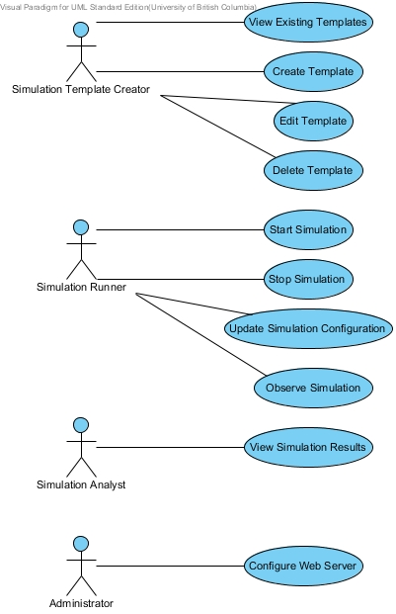
Figure 1: Use Case Diagram

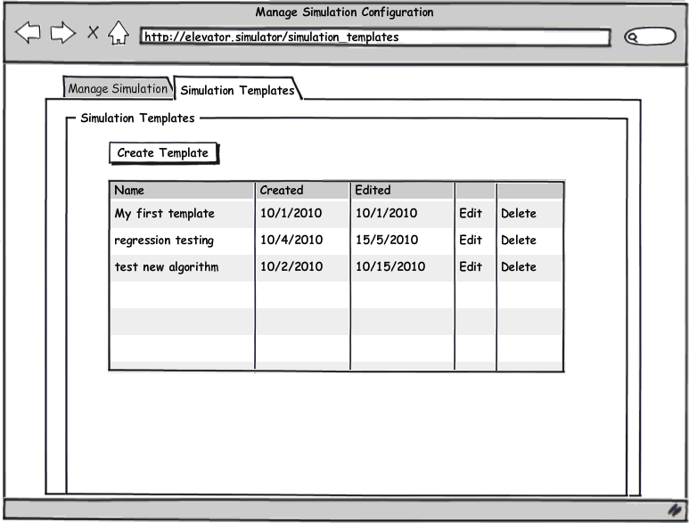
Figure 2: Viewing Existing Templates Mock-Up

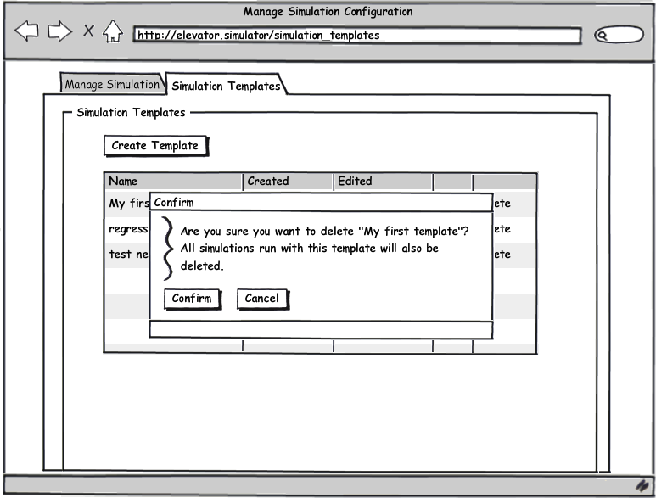
Figure 3: Deleting a Template Mock-Up

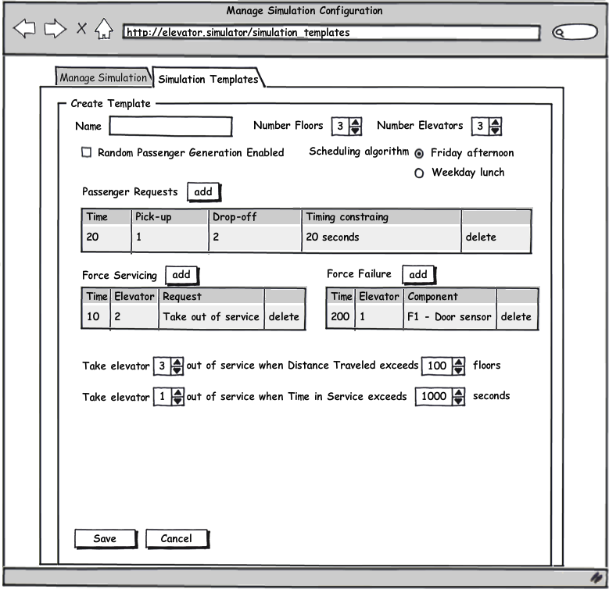
Figure 4: Creating a Template Mock-Up
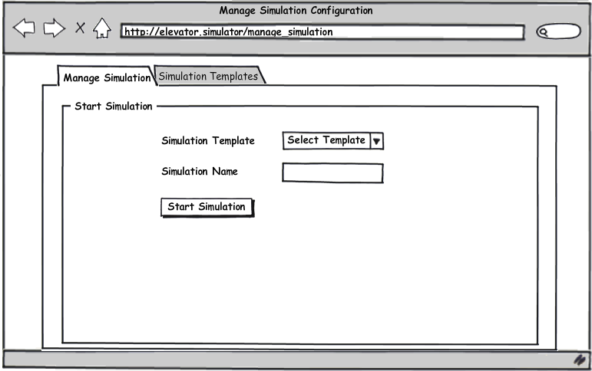
Figure 5: Starting a Simulation Mock-Up
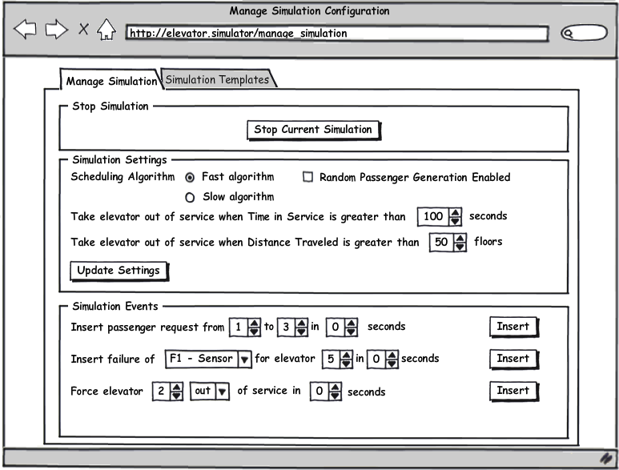
Figure 6: Stopping a Simulation and Updating Simulation Configuration Mock-Up
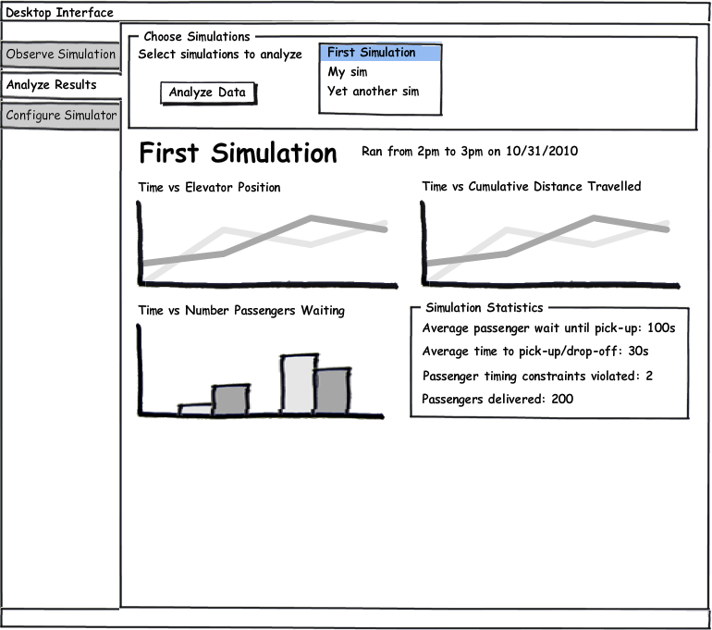
Figure 7: Viewing Simulation Results Mock-Up

Appendix B: Issues List
- TBD: Finalize user interface mock-ups.
- TBD: Finalize data and statistics displayed during analysis.
- TBD: Finalize available template options.

